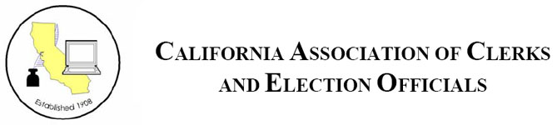

RESOLUTION

A RESOLUTION celebrating the 50th anniversary of the Voting Rights Act of 1965 on August 6, 2015.
WHEREAS, On August 6, 1965, President Lyndon B. Johnson signed the Voting Rights Act into law; this landmark piece of federal legislation prohibits racial discrimination in voting; Congress later amended the Act five times to expand its protections; and
WHEREAS, the Act was designed to enforce the voting rights guaranteed by the Fourteenth and Fifteenth Amendments to the United States Constitution, the Act allowed for a mass enfranchisement of racial minorities throughout the country; and
WHEREAS, the Act contains numerous provisions that regulate the administration of elections and provide nationwide protections for voting rights; and
WHEREAS, the Act requires jurisdictions containing significant language-minority populations to provide bilingual ballots and other election materials; and
WHEREAS, the Act has been the single most effective tool in protecting the right to vote and assuring the integrity of the voting process in this century; and
NOW, THEREFORE BE IT RESOLVED, that the ____ County Registrar does hereby join with the California Association of Clerks and Election Officials to commemorate the 50th anniversary of the Voting Rights Act of 1965 on August 6, 2015. We honor its significance; and
BE IT FURTHER RESOLVED, that ____ County Registrar will continue to protect the rights of voters in the County of ____.
BE IT FURTHER RESOLVED, that we recognize the great contributions and achievements of our government leaders and civil rights activists for encouraging participation in the democratic process and protecting voter rights.

